

**Software Engineering**

**Group Alpha**

**Group Members**

**Beresford Groenewaldt : 201308739**

**Tuahafeni Shishiiveni : 200640739**

**Sanette Sheetekela : 201305744**

**Gift Musweu : 201310548**

**Chisanga Nyambe : 201401757**

**Table of content**

1. A brief description of the client you plan to work with, including a rationale for why you chose this client…………………………………………………………………………….
2. A brief description of the problem you will analyze……………………………………….
3. A preliminary analysis of the project requirements………………………………………..
4. A motivation of the agile method ………………………………………………………….
5. Suggested deliverables …………………………………………………………………….
6. A brief communication plan how will you keep in contact with the client to report progress……………………………………………………………….................................
7. A table that indicates the contribution of each team member……………………………..
8. Review the feasibility study for the project you have chosen……………………………..
9. A short report that summarizes the requirements and the methods you used to gather these requirements, and other relevant discussions you had with the client………………………………………………………………………………………..
10. Document any interesting lessons learned during the elicitation process………………….
11. Diagrams
    1. Class diagrams………………………………………………………….....................
    2. Use case diagrams……………………………………………………………………
    3. State case diagrams…………………………………………………………………..
    4. Sequence diagram…………………………………………………………………..
12. Pattern
    1. MVC…………………………………………………………………………………
13. Architectural design………………………………………………………………………..
14. Test cases…………………………………………………………………………………..
15. Conclusion…………………………………………………………………………………
16. References...………………………………………………………………………………..
17. **A brief description of the client you plan to work with, including a rationale for why you chose this client.**

ELS event supply Cc is a company that deals with events. They hire out and sell Tents, chairs, tables, table cloths, carpets, stages and wedding gowns. They operate their business in Namibia only. Any customer that need to book any of the mentioned above products they need to visit their website for detailed information. The reason why they decided to change their booking pattern from manual to web based system is because it helps them to manage the customers booking easily and it is also reliable. This will also help the administrators to keep track of their customer’s online booking request and be able to give a quick feedback to their customer’s request. We chose this client because we feel like the website would be a great platform to exhibit her products and also extend the business exposure to all the potential customers. Through this she is also able to reach out to as many clients as possible, as the website would be accessible from anywhere around the country.

1. **A brief description of the problem you will analyze.**

Our client, ELS event supply Cc, has an issue with efficiently acquiring clients remotely, and as a result ELS is experiencing few problems which are affecting the development of the business. According to our observation and different information gathered, we came to a conclusion that, the business has a very hard time advertising their business to people all over the world. The other problem we encountered was the conflicts that arise when the customer’s wants to make a booking, and also the misunderstanding that arise when the customers makes a booking of what is not available in stock. This usually happens due to the database which is not implemented to store all the information about each client and their information.

Our client has an issue with professional exposure by not having a website where there is a thorough review about the company and what they offer to customers. Because the company has so many things to offer, it is difficult to express it all in one post on any social media, not that it is not a good way of business exposure, is that the customer needs clarity on what the business is offering.

1. **A preliminary analysis of the project requirements**

We will be creating a website for the client, which will be used for the selling and hiring of event equipment like tents, table cloths, chairs etc.

Preliminary analysis:-

* 1. There will be code scanning to make sure there are no mistakes
  2. Making sure the database of the website is update with all the required items with the right prices.
  3. All information is collected of all the items that to be put on the website like the items with the correct price etc.
  4. With the client meetings, we will analyze that all requirements are not met.

1. **A motivation of the agile method**

According to (Somerville, 2009) agile development is referred to a phrase used to describe methodologies for incremental software development. So what agile basically does it breaks down larger projects into small and manageable chunks called iterations, unlike in waterfall project management which is strictly sectioned.

The reason why we chose to use agile method is because it’s the most effective method used when developing small systems, since it focuses on keeping code simple. Agile method also reduces overheads in the software process and to be able to respond quickly to changing requirements without excessive rework. The other reason why we chose agile method approach is because of the customer’s involvement. What happens here is that the customers provides and prioritizes new system requirements and evaluate the iterations of the system. Furthermore, agile method is used for incremental delivery. Here the customer is able to specify the requirements that are to be included in each increment. In agile approach, embracing changes is also easy as we are able to accommodate the changes that are to be made to the design. Lastly, agile empowers teams to continuously re-plan their release to optimize its value through development, allowing them to be a competitive as possible in the market place.

1. **Suggested deliverables**
2. Marketing study
3. Preliminary project plan
4. Requirements specification
5. Analysis [object model and user interface]
6. Architecture specification
7. Component/ object specification
8. Source code
9. Test plan
10. Final product/ demo
11. **A brief communication plan how will you keep in contact with the client to report progress.**

The client is a very busy business person and she travels a lot, and setting up a fixed meeting timeline with her in person could be somehow difficult at times. However, she highlighted that whenever she is not available for a meeting with Alpha, she would always offer her full cooperation and support via phone or email.

1. **A table that indicates the contribution of each team member**

|  |  |
| --- | --- |
| **Contributions** | **Names** |
| A brief description of the client you plan to work with, including a rationale for why you chose this client. | Tuhafeni Shishiiveni |
| A brief description of the problem you will analyze. | Beresford Groenewaldt |
| A preliminary analysis of the project requirements | Chisanga Nyambe |
| A motivation of the agile method | Sanette Sheetekela |
| Suggested deliverables | Gift Musweu |
| A brief communication plan how will you keep in contact with the client to report progress. | Tuhafeni Shishiiveni |
| Review the feasibility study for the project you have chosen. | Chisanga Nyambe |
| Write a short report that summarizes the requirements and the methods you used to gather these requirements, and other relevant discussions you had with the client. | Beresford Groenewaldt |
| Document any interesting lessons learned during the elicitation process. | Gift Musweu |
| Documented the report | Sanette Sheetekela |

1. **Review the feasibility study for the project you have chosen.**

A feasibility study is an analysis of the viability of an idea through a disciplined and documented process of thinking through the idea from its logical beginning to its logical end. The purpose of feasibility study is carried out in order to assess the viability of a new project, since this is the primary and most important thing in development of a project.

**Project description**: ELS event supply Cc is a small company that deals with events and hires out and sells tents, table cloths, chairs, wedding gowns etc. This company has recording details of its members which are done manually on paper. Registering new member is very slow and files are easily lost.

The feasibility study we choose for our project, is the market feasibility because with this we are able to determine facility needs, suitability of product technology, availability and suitable of site and other inputs.

**Objective and solutions**: we want to grow the business by creating a website that can be used to do all the booking remotely and sell items in an efficient manner. By doing this, the registration process is also made faster, secure and reliable since it saves time, resources and can be accessed by everyone, anywhere and anytime.

**Feasible Conclusion**: The website will be a great and wonderful platform and it’s a tool that can boost and showcase the company on a bigger scale to the nation and the world.

1. **Write a short report that summarizes the requirements and the methods you used to gather these requirements, and other relevant discussions you had with the client.** 
   1. **Functional requirements**

According to (Somerville, 2009), Functional requirements defines the fundamentals actions that the system must perform. Furthermore In some cases, the functional requirements may also explicitly state what the system should not do. Our functional requirements are list below:

* + 1. The system supports customers booking able to modify them.
    2. Customers are able to search on the website and see what products are available, before they order things that are not there.
    3. When customer search for products, the search result must contain the product information (e.g. price, picture of the product etc.).
    4. Customers are able to cancel their booking.
    5. Customers can book online and with credit or debit card.
    6. Customers must be able to check for the latest promotions.
    7. Customers are able to rate the items, after reviewing them.
    8. Customers are able to check their booking status from their individual account, and also reminded of the time left before their payment is due.
    9. The system must send a booking confirmation email after successful payment.

**9.2 Non- Functional Requirements**

Somerville (2009) stated that non-functional requirements are properties that your system must have. Think of characteristics or qualities that make your system attractive, usable, fast and sure, but they are not required.

9.2.1 The system must be able to handle multiple transactions a time.

9.2.2 The system must provide customers 24/7 hours online booking service.

9.2.3 The system should send advertisements of the promotions or deals that are going on to the registered customers.

9.2.4 Customers need to cancel their booking 48 hours in advance, otherwise they will be charged a certain free for late cancellation.

**9.3 Methods we used to gather the information.**

We were able to gather all these requirements through phone calls, sit-down meetings, text messages plus a digital advertisement of what they do. With all this information gathered we were able to compile a requirements document with all the necessary user and system requirements needed to continue our development on the system.

1. **Document any interesting lessons learned during the elicitation process.**

In requirements **engineering**, requirements **elicitation** is the practice of collecting the requirements of a system from users, customers and other stakeholders. ... Requirements **elicitation** is a part of the requirements **engineering process**, usually followed by analysis and specification of the requirements. During this process we were able to determine whether the stated requirements are clear, complete, consistent and resolving any apparent conflicts.

**The best practices and lessons learned**

* 1. **Apply good interpersonal skills**: Such skills are always an asset, but they are a necessity when eliciting requirements.
  2. **Apply good interpersonal skills**: Such skills are always an asset, but they are a necessity when eliciting requirements.
  3. **Think broadly**: SEs with broad knowledge of the enterprise in which requirements are being developed (whether for a system, service, or the enterprise) adds value and may be able to identify cost-effective solutions (e.g., process changes).
  4. **Determine the root cause of the problem:** Before requirements collection starts, it is critical that the SE answer the question, like what is the real need that the project and its product are intended to address? This way you able to find the best suitable solution to the problem.

1. **UML Diagrams**

UML design is the shortest form of “**Unified Modelling Language**”. The purpose of this modelling language is to visualize the design of the system.

* 1. Class diagrams

This is the most used UML diagram in the field of software engineering design. It is called as a main building block of any object oriented solution. Usually it illustrates the classes in a system, attributes and operations of each class and also the relationship between each class. Below is the “***class diagram***” of our new proposed system.

|  |
| --- |
| ITEMS |
| -Item_no: int  -Item_name: String  1…*  -Price: Double  -Quantity: Decimal |
| +GetItem()  +GetQuantity() |

|  |
| --- |
| CUSTOMER |
| -Customer_ID: String  -Name: String  -Residential Address: String  -email: String  -telephone_no: String |
| 1 |

|  |
| --- |
| REGISTER |
| -name: String  -surname: String  -email: String |
| +Getname()  +Getemail()  +Getsurname() |

1

1

1

1

1...*

1...*

|  |
| --- |
| BOOKING |
| -Customer_name: String  -Customer_ID: String  -Rental_date: Date  -item_no: Int  -Quantity: Decimal |
| +AddBookings()  +EditBooking( int:  Bookings)  +Delete()  +RollBack() |

|  |
| --- |
| BUYING |
| -noOfItems: int  -itemName: String  -accountNumber: String |
| +Getprice()  +Getname() |

* 1. Use case diagrams

It is also called behavioral UML diagram. It gives a graphic over-view of the actors involved in a system directly. It shows how different functions needed by the actors how they are interacted.

Below is the “***use case diagram***” of our new proposed system.

User

Admin

11.3 State case diagrams

11.3.1 State case diagram for

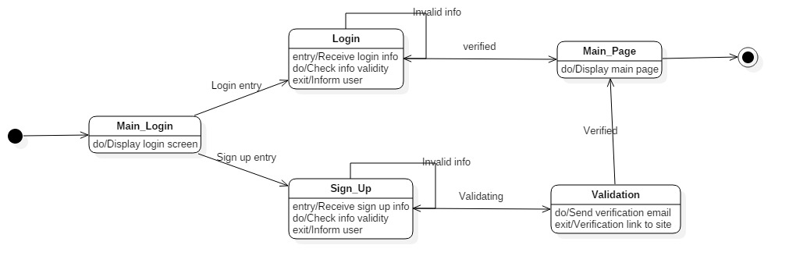

11.3.2 State case diagram for buying

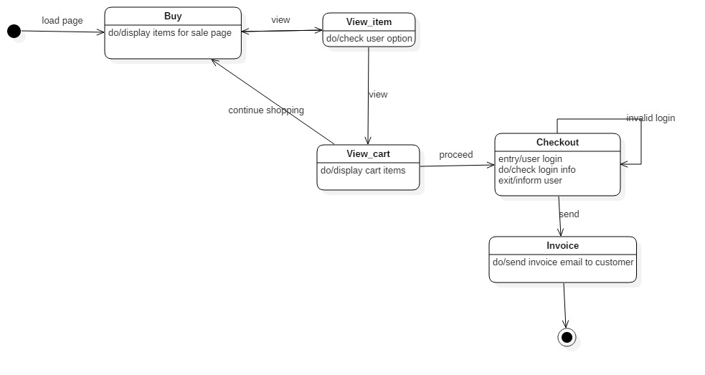

11.3.3 State case diagram for rent

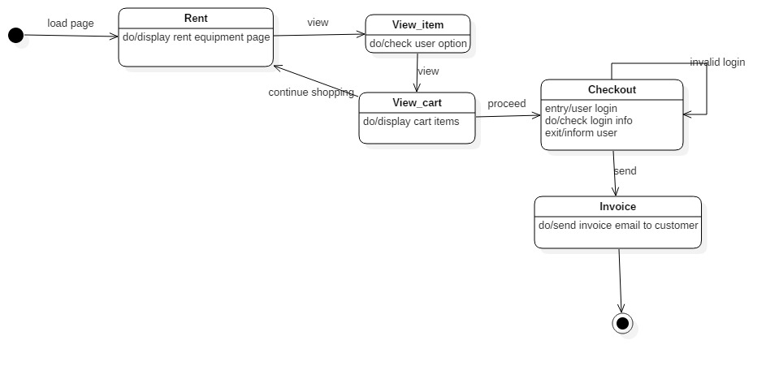

11.4 Sequence diagrams

1. **Pattern**

Model View Controller (MVC)

According to (Somerville, 2009) Model-view-controller (MVC) is referred to a type of pattern that separates presentation & interaction from the system data. The system is structured into three logical components that interact with each other, which are:

* The model component, this component manages the system data and associated operation on that data.
* The view component, this component defines and manages how the data is presented to the user.
* The controller component, this component manages interaction and passes these interactions to the view and the model.

We choose this pattern for our system, because MVC let you change the way a view responds to user input without changing its visual presentation. In addition, this model returns data without applying any formatting, the same components can be used and called for use with any interface. Furthermore, the model is self-contained and separate from the controller and the view, it’s much less painful to change your data layer or business rules. The concept of the controller is also a benefit, since it’s used to stitch together different pieces of the model and the view to fulfill a request. This places significant power into the architect’s hands.

Among the drawbacks of using MVC is that it’s not necessarily easy, and it is definitely not for everybody. MVC requires significant planning, and it introduces a deeper level of complexity that requires diligent attention to detail. Overall, this is a good approach to building software. The MVC design pattern is well-established and compelling approach to software.

1. Architectural design
2. Test cases
3. Conclusion
4. References

 Kotonya, G. and Sommerville, I. 1998. *Requirements Engineering: Processes and Techniques* Chichester, UK: John Wiley and Sons.

*Beck, A., Boeing, G., & Shannon, D. (2014).*[*"Systems and Methods for Analyzing Requirements. US Patent 8650186"*](http://geoffboeing.com/publications/systems-methods-analyzing-requirements/)*. Retrieved 2016-03-17.*

[*Chemuturi, M.*](https://en.wikipedia.org/wiki/Murali_Chemuturi)*(2013). Requirements Engineering and Management for Software Development Projects.*[*doi*](https://en.wikipedia.org/wiki/Digital_object_identifier)*:*[*10.1007/978-1-4614-5377-2*](https://dx.doi.org/10.1007%2F978-1-4614-5377-2)*.*[*ISBN*](https://en.wikipedia.org/wiki/International_Standard_Book_Number)[*978-1-4614-5376-5*](https://en.wikipedia.org/wiki/Special:BookSources/978-1-4614-5376-5)*.*

1. Glossary

Analyze

Preliminary analysis

Agile

Incremental delivery

Feasibility

Functional requirements

Non-functional requirements

Elicitation process

Class diagram: illustrates the classes in a system, attributes and operations of each class and also the relationship between each class

Use case diagram: shows how different functions needed by the actors how they are interacted.

State case diagram

Sequence case diagram

Pattern

Test cases